**LF AND AI DATA FOUNDATION**

**INTRODUCTION**

What is LF AI & Data?

LF AI & Data is **an umbrella foundation of the Linux Foundation that supports open source innovation in artificial intelligence (AI) and data**.

**LF**

**LF Energy is a Linux Foundation Project that Supports multi-vender collaboration and open source innovation in the energy.**

The **Linux Foundation** (**LF**) is a [non-profit](https://en.wikipedia.org/wiki/Nonprofit_organization) technology consortium founded in 2000 as a merger between [Open Source Development Labs](https://en.wikipedia.org/wiki/Open_Source_Development_Labs) and the [Free Standards Group](https://en.wikipedia.org/wiki/Free_Standards_Group) to standardize [Linux](https://en.wikipedia.org/wiki/Linux), support its growth, and promote its commercial adoption. Additionally, it hosts and promotes the collaborative development of [open source](https://en.wikipedia.org/wiki/Open-source_software) software projects. It is a major force in promoting diversity and inclusion in both Linux and the wider open source software community.

The foundation was launched in 2000, under the [Open Source Development Labs](https://en.wikipedia.org/wiki/Open_Source_Development_Labs) (OSDL) and became the organization it is today when OSDL merged with the [Free Standards Group](https://en.wikipedia.org/wiki/Free_Standards_Group) (FSG). The Linux Foundation sponsors the work of Linux creator [Linus Torvalds](https://en.wikipedia.org/wiki/Linus_Torvalds) and lead maintainer [Greg Kroah-Hartman](https://en.wikipedia.org/wiki/Greg_Kroah-Hartman). Furthermore, it is supported by members, such as [AT&T](https://en.wikipedia.org/wiki/AT%26T), [Cisco](https://en.wikipedia.org/wiki/Cisco), [Fujitsu](https://en.wikipedia.org/wiki/Fujitsu), [Google](https://en.wikipedia.org/wiki/Google), [Hitachi](https://en.wikipedia.org/wiki/Hitachi), [Huawei](https://en.wikipedia.org/wiki/Huawei), [IBM](https://en.wikipedia.org/wiki/IBM), [Intel](https://en.wikipedia.org/wiki/Intel), [Meta](https://en.wikipedia.org/wiki/Meta_Platforms),[[6]](https://en.wikipedia.org/wiki/Linux_Foundation#cite_note-6) [Microsoft](https://en.wikipedia.org/wiki/Microsoft),[[7]](https://en.wikipedia.org/wiki/Linux_Foundation#cite_note-7) [NEC](https://en.wikipedia.org/wiki/NEC), [Oracle](https://en.wikipedia.org/wiki/Oracle_Corporation), [Orange S.A.](https://en.wikipedia.org/wiki/Orange_S.A.), [Qualcomm](https://en.wikipedia.org/wiki/Qualcomm), [Samsung](https://en.wikipedia.org/wiki/Samsung), [Tencent](https://en.wikipedia.org/wiki/Tencent), and [VMware](https://en.wikipedia.org/wiki/VMware), as well as developers from around the world.

In recent years, the Linux Foundation has expanded its support programs through events, training and certification, as well as open source projects. Projects hosted at the Linux Foundation include the [Linux kernel](https://en.wikipedia.org/wiki/Linux_kernel) project, [Kubernetes](https://en.wikipedia.org/wiki/Kubernetes), [Automotive Grade Linux](https://en.wikipedia.org/wiki/Automotive_Grade_Linux), [ONAP](https://en.wikipedia.org/wiki/ONAP) (Open Network Automation Platform), [Hyperledger](https://en.wikipedia.org/wiki/Hyperledger), [Cloud Native Computing Foundation](https://en.wikipedia.org/wiki/Cloud_Native_Computing_Foundation), [Cloud Foundry](https://en.wikipedia.org/wiki/Cloud_Foundry) Foundation, [Xen](https://en.wikipedia.org/wiki/Xen) project, and many others.

**AI**

Artificial intelligence is a science and technology based on disciplines such as Computer Science, Biology, Psychology, Linguistics, Mathematics,and Engineering. A major thrust of AI is in the development of computer functions associated with human intelligence, such as reasoning, learning, and problem solving.

Over the course of the last decade, the landscape of AI and data technologies has begun to rely heavily on the open source community. We have seen a shift both in enterprise adoption of open source software as well as an increased reliance on open source software in the base of proprietary software solutions that provide value-added capabilities on top of the open source distribution. These value-added capabilities can range from the creation and management of ‘enterprise grade’ distributions that began, in the early 20-teens, with Python, R, and Hadoop leading the charge. The primary governing foundations for these distributions are the Apache Foundation and the Linux Foundation as these governing bodies provide a governance and license structure that is more conducive to enterprise adoption. The Linux Foundation and its AI and Data umbrella foundation (LF AI & Data) are critical to our (IBM’s) strategy as we rely heavily on the consumption of LF AI & Data projects, the contribution to LF AI & Data projects, and the founding of new AI and data projects and committees hosted in LF AI & Data. This is exemplified in our standing as one of the leading contributors to LF AI & Data and a leading contributor to the Linux Foundation. As one of the major AI and data vendors, we see a responsibility to make certain technologies available freely to the world in AI as it relates to the robustness of AI, the fairness of AI, and the explainability of AI.

**PROJECT SUMMARY**

|  |  |
| --- | --- |
| Website | <https://lfaidata.foundation/> |
| wiki | [Technical Advisory Council Home](https://wiki.lfaidata.foundation/pages/viewpage.action?pageId=7733341) |
| Organization/Foundation Name | LF AI AND DATA FOUNDATION |
| Open/Proprietary | Open source |
| Landscape | <https://landscape.lfaidata.foundation/> |
| Artwork | [https://artwork.lfaidata.foundation](https://artwork.lfaidata.foundation/) |
| Github | <https://github.com/lfai> |
| Source Path | https://lfaidata.foundation/projects/ |
| Brief Description | LF AI & Data was created to support open source AI and data, and to create a sustainable open source AI and data ecosystem that makes it easy to create AI and data products and services using open source technologies. |

**PROJECT DETAILS**

**KEY FEATURES AND BENEFITS**

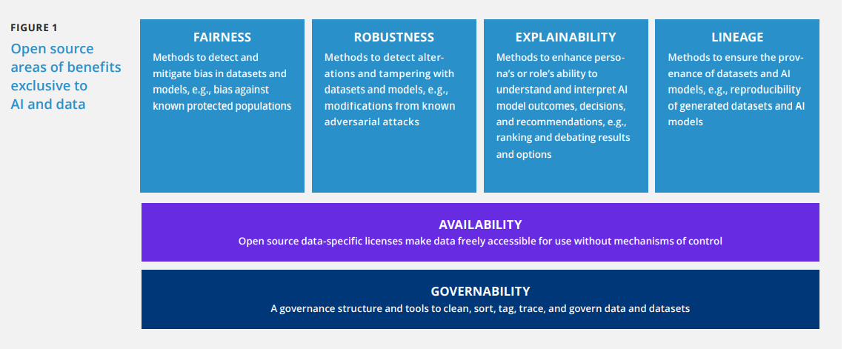**ARCHITECTURE AND DIAGRAM OF LF AND AI**

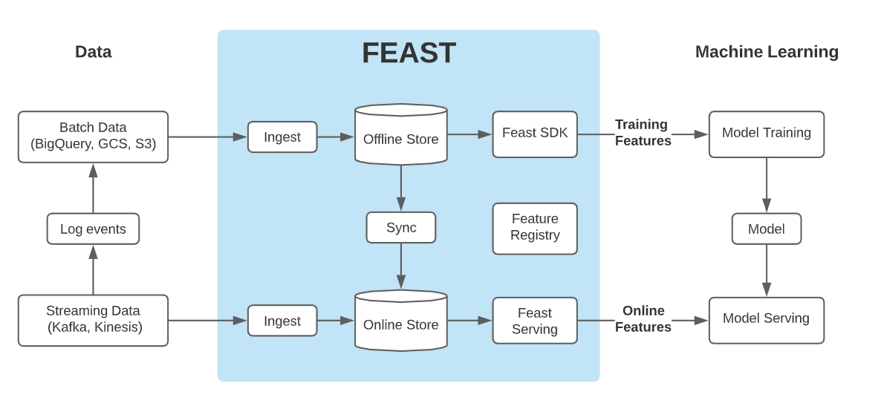

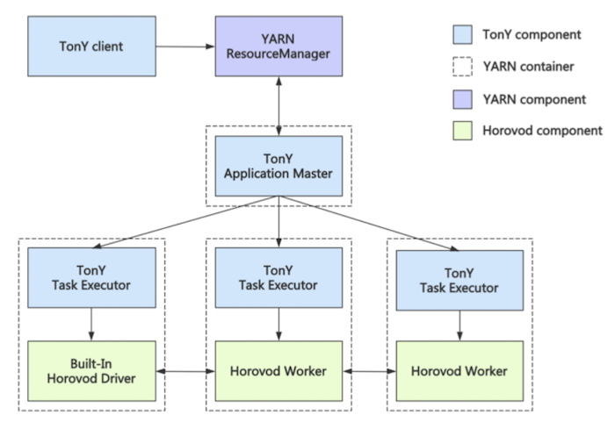

**MODULAR PLATFORM**

LF & AI is a platform and open source framework that makes it easy to build for,…..

* Creating
* Reproducible
* Maintainable
* Modular data science code

**INTEGRATED DATA OF LF AND AI**

The **LF AI** & **Data Foundation** supports open source projects within **artificial** ... It provides open APIs, event formats, types and **integration** logic

**TECHNICAL DETAILS**

The mission of **LF AI** & **Data** is to build and support an open **artificial intelligence** (**AI**) and **data** community, and drive open source innovation in the **AI** and **data.**

**OTHER INFORMATION ABOUT LF & AI DATA**

1. The Path Way To Leadership In Open Source

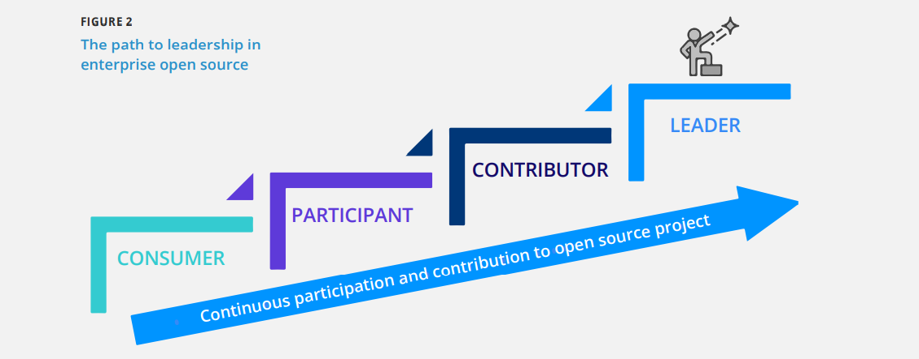

1. Open Source AI and Data Ecosystem

Our goal is to help developers, end-users, and others to navigate the complex ecosystem landscape. Anyone can contribute by submitting a pull request on GitHub. To that end, the LF AI & Data Foundation has created an interactive landscape 1 . It represents

* 316 open source AI and data projects
* 500 million+ lines of code (LoC) and growing at an average weekly rate of one million LoC
* 35,000+ active developers contributing code
* 15 open source licenses
* 18 countries of project origin
* 102 companies founded projects
* 10 open source foundations hosting multiple projects
* 12 universities founded projects

**In the landscape, we organized the 316 open source projects into 11 categories:**

* Deep learning (four subcategories)
* Reinforcement learning
* Programming
* Model (eight subcategories)
* Trusted and responsible AI (three subcategories
* Distributed computing (two subcategories)
* Security and privacy
* Natural language processing
* Notebook environment
* Machine learning (four subcategories)

**Open Source AI & Data landscape**

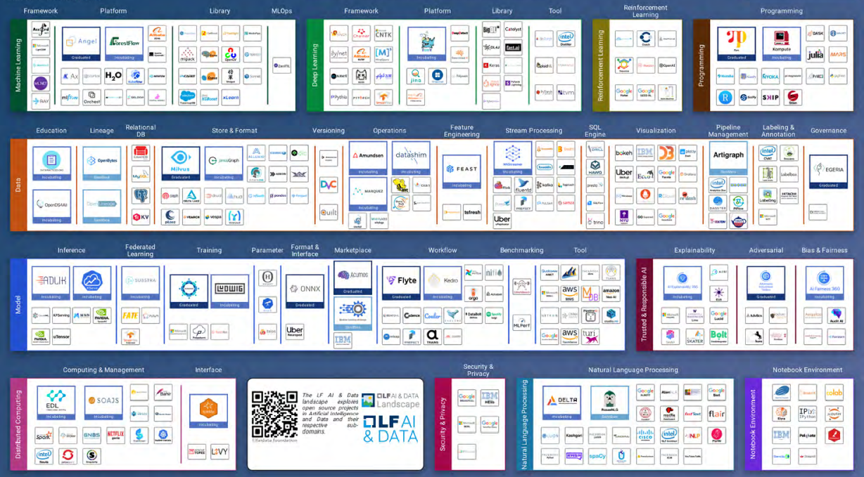

**Comprehensive list of services to LF AI & Data hosted projects**

* **NEUTRAL** **HOSTING**

A neutral home for an open source project increases the willingness of developers from software companies, startups, academia, and elsewhere to collaborate, contribute, and become committers.

* **DEDICATED STAFF**

Projects have access to full-time staff (executive director, program manager, project coordinator) who cultivate the maturity and adoption of open source AI and data projects

* **TRAINING AND CERTIFICATION**

We develop training classes and, through the Linux Foundation, can execute and launch certification programs in support of hosted projects.

* **EVENTS MANAGEMENT**

Events are part of LF AI & Data’s core strategy to help projects build a community and accelerate knowledge-sharing and integration. Many LF AI & Data projects have their own events.

* **DEV-FOCUSED OPERATION**

Services include IT infrastructure, release management, IT ops, support, security audits, and a host of tools (FOSSA, LastPass, Slack, Synk, Zoom, etc.)

* **MENTORSHIP**

Members of the LF AI & Data technical advisory committee and leaders of graduated projects are available to support and mentor new projects

* **LEGAL SERVICES**

We help projects navigate licensing requirements, IP regimes, trademark management, compliance scans, export control filings, and developer certificate of origin or contributor license agreement integration with GitHub, etc..

* **MARKET SERVICES**

We offer a wide range of marketing services to increase project awareness, project adoption, and the number of contributors.

* **DESIGN AND AESTHETICS**

Our in-house team provides graphic design resources for new logos, websites, and website refreshes or enhancements.

* **PROGRAM MANAGEMENT**

We have decades of experience in program management of open source projects. We bring best practices to all LF AI & Data hosted projects

* **LFX PLATFORM EXPERIENCE**

This Linux Foundation product offers a set of integrated tools for project insights, security, easy contributor license agreements, crowdfunding, member engagement, and more.

**Acknowledgement/Reference**

[**https://lfaidata.foundation/**](https://lfaidata.foundation/) **was referred to gain information about key benefits and information, architecture, data landscape, comprehensive and data host projects.**

[**https://en.wikipedia.org/wiki/Linux_Foundation**](https://en.wikipedia.org/wiki/Linux_Foundation) **was referred for introduction section.**